7.57: The two design conditions are expressed algebraically as 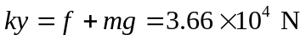 (the condition that the elevator remains at rest when the spring is compressed a distance y; y will be taken as positive) and 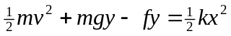 (the condition that the change in energy is the work 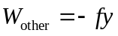). Eliminating y in favor of k by 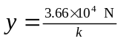 leads to

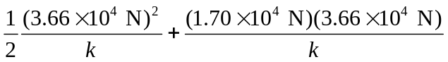
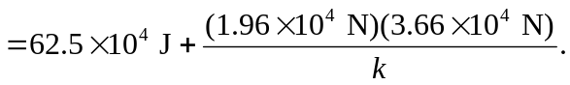

This is actually not hard to solve for 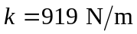, and the corresponding x is 39.8 m. This is a very weak spring constant, and would require a space below the operating range of the elevator about four floors deep, which is not reasonable. b) At the lowest point, the spring exerts an upward force of magnitude 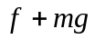. Just before the elevator stops, however, the friction force is also directed upward, so the net force is 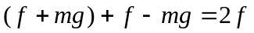, and the upward acceleration is 

